Problem: Spaghetti communication

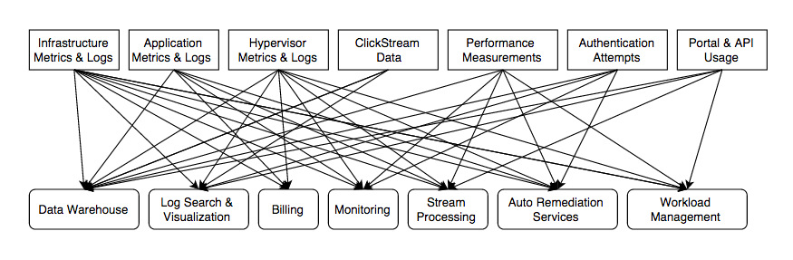

Solution: Kafka

